Cinematic techniques in movies, commercials and documentaries
- An analysis method

- Look at the film
- Describe what we see

- Identify the film’s cinematic techniques

- The use of framing
  - For example close-up, long shot, knee shot etc.

- The use of lighting
  - For example high-key/low key etc.

- The use of editing
  - For example fast pace, slow pace, montage etc

- The use of camera movement
  - Hand held, helicopter/drone shot, travelling shot, zoom etc.

- The use of camera angle
  - High, low or neutral angle

- The use of sound
  - Music (which kind), silence, voice over, sound effects

- Argue for the effect of the use of cinematic techniques

For more cinematic techniques and a description, you may refer to the book ”Levende Billeder” on systime.dk – or www.filmcentralen.dk/gymnasiet/filmsprog

Look below where you can find more on framing and angles

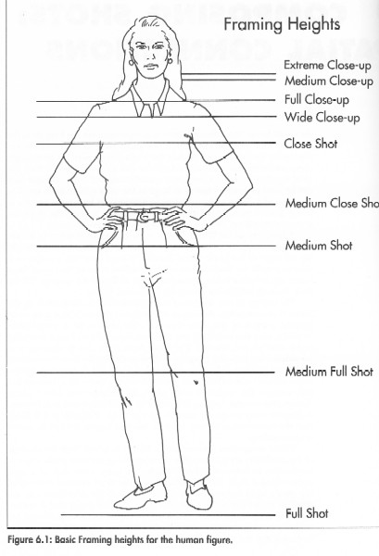 | 