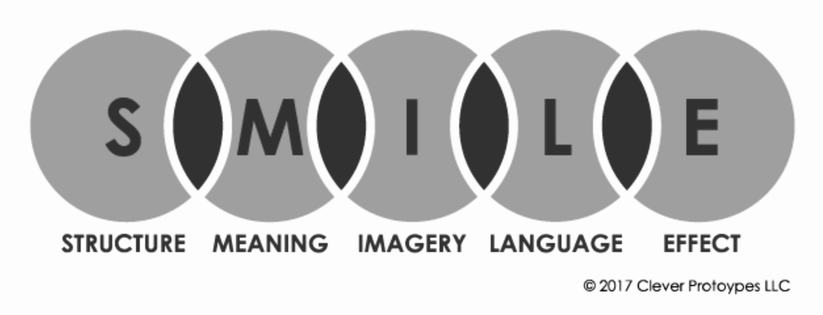
https://www.storyboardthat.com/articles/e/smile-poetry-analysis

Structure
The structure refers to the physical and grammatical composition of the poem. For this element, you should consider the following for your poetry analysis:
- number of verses/stanzas
- comparative length of verses/stanzas (regular or irregular)
- line length
- rhyme scheme
- repetition, including refrains
- enjambment
- sentence structure and grammar
- punctuation or lack thereof

Meaning
In identifying the meaning, you should be able to articulate the basic subject of a poem along with its deeper significance. To truly capture meaning, a reader must also be able to accurately identify a poem's message or theme. Often this requires working out a poem’s figurative meaning. In Robert Frost’s “The Road Not Taken”, for example, the basic subject conveys a man walking in the woods who has difficulty deciding which path to take. To fully understand the poem, however, readers must recognize that the forest paths represent the journey of life, and the poem’s message reminds us that each choice in life has irrevocable consequences. It is often useful to establish a poem’s basic meaning and then revisit step M for a poem’s deeper significance following further analysis of other elements (steps ILE).

Imagery
Imagery refers to language that appeals to one of the five senses - touch, taste, smell, sound, and sight. Imagery helps strengthen a writer's description by providing physical details that enable the reader to better imagine the scene or understand the speaker's feelings. Imagery can contain figurative language, but does not have to, as in the examples below, taken from “City Autumn” by Joseph Moncure March.

No figurative language: A thin wind beats/ Old dust and papers down gray streets
Figurative language: A snowflake falls like an errant feather

Both examples of imagery in “City Autumn” give us a visual picture of the autumn weather. One does so with a literal description and the other with an effective simile.
By adding imagery to a particular object, person, or scene, the writer heightens the importance of that detail and helps add negative or positive value to it.

Language
Language refers to a writer's diction, or word choice. Use of figurative language should be noted here and interpreted, along with sound devices, repetition, the speaker' dialect, and particularly significant words. Students may find the questions below useful when analyzing poetic language.
- Does the poem contain metaphor, simile, personification, hyperbole or other figurative language?
- Does the poem play with sound using alliteration, assonance, repetition, or rhyme?
- Are there any words that are particularly sophisticated or especially basic? Does the rhyme, for example, depend on words like “hog” and “dog” or “absolution” and “circumlocution”?
- Does the poem contain formal or informal dialect? Does the speaker seem to come from a particular region, country, or cultural background?

Effect
In determining a poem's effect, readers can include their initial reactions. How do they feel after reading it? What is the mood of the poem? The readers should also review this element after studying the other four (SMIL). In this way, students can consider the effect of the poem's structure, imagery, language, and message as they work together.

