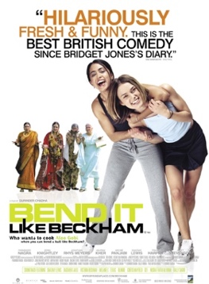
BEND IT
Like Beckham – and multiculturalism in Great Britain

Before watching the movie Bend it Like Beckham work with the assignments in the grey boxes

While you watch the movie work with the assignments in the orange box

After you have watched the movie work with the assignments in the blue box

At the bottom of this document, you will find the yellow tool box with four analysis models to remind you how to work correctly with the various assignments – you will analyse poetry, non-fiction, culture and cinematic techniques in the assignments in this document.

Local Colour - Liz Lochhead
Something I’m not familiar with, the tune
of their talking, comes tumbling before them
down the stairs which (oh I forgot) it was my turn
to do again this week
my neighbour and my neighbour’s child. I nod, we’re not on
speaking terms exactly

I don’t know much about her. Her dinners smell
different. Her husband’s a busdriver,
so I believe.
She carries home her groceries in Grandfare bags
though I’ve seen her once or twice around the corner
at Shastri’s for spices and such.
(I always shop there – he’s open ‘till all hours
making good.) How does she feel?

Her children grow up with foreign accents,
swearing in fluent Glaswegian. Her face
is sullen. Her coat is drab plaid, hides
but for a hint at the hem, her sari’s
gold embroidered gorgeousness. She has
a jewel in her nostril.
The golden hands with the almond nails
that push the pram turn blue
In this city’s cold climate

Glossary list
(to) be familiar with – (at) kende
tune - melodi
tumbling - væltende
(to) nod – (at) nikke
speaking terms - talefod
exactly – præcis, rigtigt (“man kan ikke sige, at vi er på…)
groceries – købmandsvarer, indkøb
Grandfare – navn på supermarked; “grand” = god glimrende; “fare” = køb eller mad)
spice - krydderi
making good “og klarer sig godt”, “og har success”
(to) swear – (at) bande
fluent - flydende
sullen - trist
drab – kedelig, gråbrun
but for – bortset fra
hint - antydning
hem – søm, kant (på stof)
gorgeousness – pragt, skønhed, “vidunderlighed”
jewel - juvel
nostril - næsebor
almond – mandel, her: mandelfarvet eller -formet
pram – barnevogn

Glaswegian is the dialect spoken in Scotland’s biggest town Glasgow – an old industrial town. Home to many from the working class

Useful words
tenement building – etagebolig (typisk 4-5-6 etager)
alienantion – fremmedgørelse
to feel/be alienated – at føle sig/være fremmedgjort

- Find information about the author Liz Lochhead

- Find information about when the poem was written/spoken – if possible

- Where do you think the poem takes place?

- This type of poem is called “dramatic monologue” – what do you think this means? Can you find examples in the poem that suggests this?

- Use the SMILE poetry analysis model on the poem

Multiculturalism in London
From http://worldpopulationreview.com/world-cities/london-population/

Ethnicity in London
London as a city is considerably more diverse than the rest of the United Kingdom. Across England and Wales, 86% of the population is white based on the 2011 Census, but in London that number falls to 69.7%. The white proportion of London's population increases when traveling away from the city center.

The section on ethnicity below, compiled using 2011 census data from the ONS provides details of the ethnicity of London residents compared to residents of England and Wales.

London's diversity can also be seen in statistics for London residents' country of birth. Of the 8.88 million people living in London at the time of the most recent UK estimates, 3.32 million (37%) were born outside of the United Kingdom. Of these, approximately a third were born within European Union countries, while the other two thirds were born outside of the European Union. The most common country of birth for London residents outside of the UK is India. According to the 2011 census, 262,247 people living in London were born in India.

Religion in London
London is the most diverse area within the UK when it comes to religious beliefs, with the highest percentage of people identifying as Muslim, Buddhist, Hindu or Jewish. The latest data from the 2011 census recorded that 48.4% of Londoners considered themselves to be Christian, 12.39% considered themselves Muslim, 5% Hindu, 1.82% Jewish, 1.5% Sikh, 1% Buddhist and 0.6% Other. A large proportion, 20.73% of respondents, stated that they followed no religion.

Ethnicity in London vs Rest of United Kingdom
Place | White | Asian | Black | Mixed | Other
East Midlands | 89.3% | 6.5% | 1.8% | 1.9% | 0.6%
East of England | 90.8% | 4.8% | 2% | 1.9% | 0.5%
England and Wales | 86% | 7.5% | 3.3% | 2.2% | 1%
London | 59.8% | 18.5% | 13.3% | 5% | 3.4%
North East | 95.3% | 2.9% | 0.5% | 0.9% | 0.4%
North West | 90.2% | 6.2% | 1.4% | 1.6% | 0.6%
South East | 90.7% | 5.2% | 1.6% | 1.9% | 0.6%
South West | 95.4% | 2% | 0.9% | 1.4% | 0.3%
Wales | 95.6% | 2.3% | 0.6% | 1% | 0.5%
West Midlands | 82.7% | 10.8% | 3.3% | 2.4% | 0.9%
Yorkshire and the Humber | 88.8% | 7.3% | 1.5% | 1.6% | 0.8%

- What catches your attention by looking at these statistics?

Bend it Like Beckham synopsis

A kaleidoscope of colour and culture clash humorously as an Indian family in London tries to raise their soccer-playing daughter in a traditional way. Unlike tarty elder sister Pinky, who is preparing for an Indian wedding and a lifetime of cooking the perfect chapatti, Jess' dream is to play soccer professionally like her hero David Beckham. Wholeheartedly against Jess' unorthodox ambition, her parents eventually reveal that their reservations have more to do with protecting her than with holding her back. When Jess is forced to make a choice between tradition and her beloved sport, her family must decide whether to let her chase her dream...and a soccer ball. (http://www.foxsearchlight.com/benditlikebeckham/)

- What tells you that this movie has very typical British cultural elements?
- What tells you that this movie has elements of culture clash?
- What do you think the conflicts in the movie will be?

Bend it Like Beckham and the art of Balancing Cultures

Read the article in the link below.

https://www.theatlantic.com/entertainment/archive/2017/04/bend-it-like-beckham-and-the-art-of-balancing-cultures/522477/

- Find at least 10 words you believe are difficult to you or your classmates - explain and translate them.

- How did the movie Bend it Like Beckham help the author? Give more than one reason – there are several examples throughout the article.

- According to the author, how does Jessminder, the main character of Bend it Like Beckham, balance her two cultural identities? Give more than one example

- In which ways are Jessminder and the author of the article the same?

- Identify places where ethos, logos and pathos are used in the article

- Analyse the article by using the rhetorical pentagon

  - Who is the writer? Where is the article published?
  - What is the topic of the article?
  - Which language is used?
  - Under which circumstances was the article written?
  - Who is the intended reader?

While watching Bend it Like Beckham

Study questions for while you watch the movie - or shortly after.

- British culture: (Make a list)
  - Identify symbols, heroes, traditions and values (Onion Diagram) that are seen or mentioned in the movie

- Indian culture: (Make a list)
  - Identify symbols, heroes, traditions and values (Onion Diagram) that are seen or mentioned in the movie

- Cinematic techniques in Bend it Like Beckham
  - List some of the cinematic techniques that are used in the movie

After watching the movie

Study questions that you must answer after you have watched the movie

- Describe the two main characters, Jessminder (Jess) and Juliette (Jules)

- Describe the two main characters’ differences and similarities

- List some of the themes that the movie deals with

- Based on your lists from the work in the orange box above, compare the differences and similarities between British and Indian culture
  - What do the differences tell you in relation to the various conflicts of the movie?

- Explain why your various listed cinematic techniques are used in the movie – and the effect they have on the viewer

- What is the message of the movie?

- Draw perspectives to historical or current events or situations in our society

TOOL BOX

SMILE analysis model for poetry  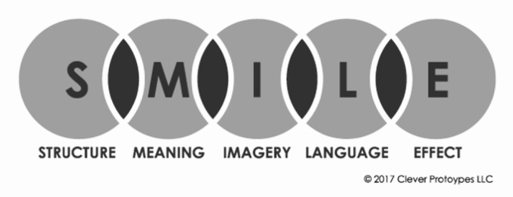  Rhetorical pentagon for analysing non-fiction  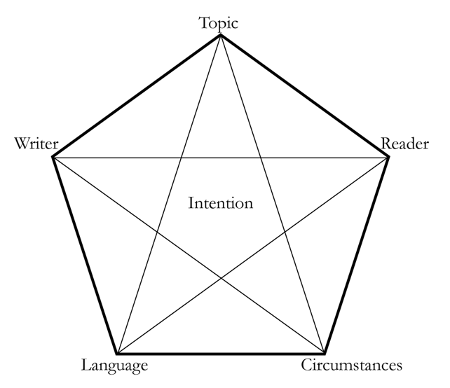 | Onion Diagram for cultural analysis  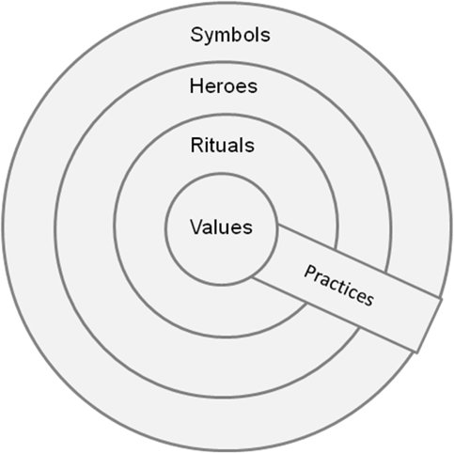  Cinematic techniques for analysing movies  